INTRODUCTION

The subject of this overview is the Scenix V.23 modem reference design. Scenix Semiconductor, Inc., has completed a design for a V.23 modem, operating in originate mode, to suit the needs of some of its customers. This document is a brief overview of some of the functions performed by the V.23 modem, and the methods by which they are accomplished.

An overview of the modem design follows:

User Interface

- Universal Asynchronous Receiver/Transmitter Specifications
- 1200 baud
- No Parity
- 8 Data Bits
- 1 Stop Bit
- Hardware Flow Control (CTS, RTS)

The UART is integrated into the Interrupt Service Routine of the software, which runs every 3.26us. The UART runs on every 16th pass of the ISR, or every 52.16 microseconds. The bit time for a 1200bps UART is 83.33 milliseconds. Dividing 83.33 milliseconds by 52.16us gives a result of 15.97, or 16, an easy divide ratio in any binary system.

- Compact AT command set
- 64-byte command buffer
- Dial: “ATDTxxxxxxxxx…”
- Switch from data mode to command mode: “+++”
- Switch from command mode to data mode: “ATO”
- Hang up: “ATH”
- Initialize: “ATZ”

The AT-commands were chosen to provide enough functionality for a very simple modem design. Since the SX originate-only modem can only originate a data call, no answer functions are implemented. Incoming AT-commands are stored in a 64-byte buffer, and compared to software lookup tables on reception of a carriage return.

Signal Generation/Detection Software

- DTMF Generation for Dialing
- Tones generated: 697Hz, 770Hz, 852Hz, 941Hz, 1209Hz, 1336Hz, 1477Hz,1633Hz,
± 0.5Hz
- On time = 100ms
- Off time = 100ms
- Off-hook delay time before dialing = 4 s
- D/A conversion provided by filtered PPM output

The DTMF generation is performed completely by the software in the V.23 modem. For speed’s sake, a 32-byte lookup table is used to fetch each the next value in each sine wave. The frequency of each sine wave is selected through a 16-bit value, giving a frequency resolution of [1/(3.26us * 2¹⁶ * 32)] = 0.15Hz.
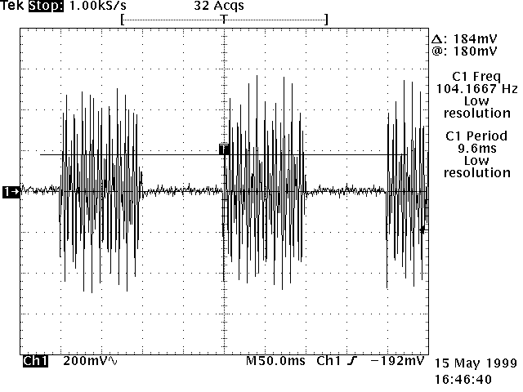
Dial Times: 100ms ON, 100ms OFF
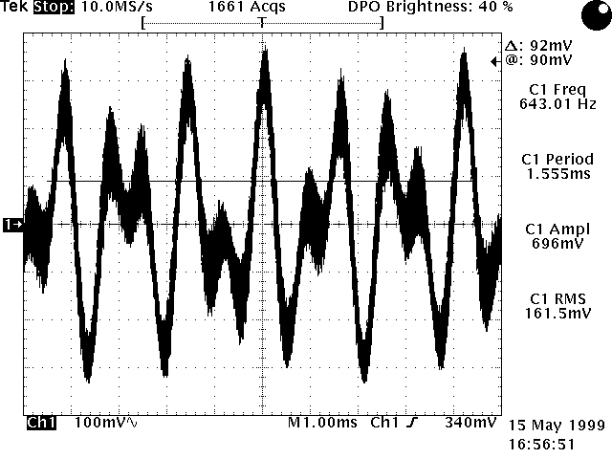
Filtered DTMF Output
- Data transmission and modulation
- FSK transmission data rate at 75bps
- Hardware flow control, 16-byte buffer, and 75bps asynchronous transmitter for data rate conversion from 1200bps to 75bps
- Logic ‘1’ (mark) modulated by 390 Hz
- Logic ‘0’ (space) modulated by 450 Hz
- Transmission power = -15dB
- D/A conversion provided by filtered PPM output

- Data reception and demodulation
- FSK reception data rate at 1200bps
- Logic ‘1’ (mark) demodulated from 1300Hz carrier
- Logic ‘0’ (space) demodulated from 2100Hz carrier
- Carrier detection
- Timed-Zero-Cross algorithm

- D/A conversion
- Pulse Position Modulation with maximum output frequency of 307kHz

Hardware Specifications

- Filtering
- Low pass filter on PPM output
- High pass filter on FSK input

- Hybrid
- Four settings provided for automatic hybrid adjustment for various line impedance’s
- Hybrid adjusted by outputting signal onto line and measuring fed-back signal with a low-resolution sigma-delta A/D converter

- FSK input sensitivity = -30dB

- UART
- RS-232 interface provided through MAX232 or similar IC
- Interface provided through RXD, TXD, RTS, and CTS lines

TECHNICAL SPECIFICATIONS

Testing Specifications

- Initial tests using function generator and off-the-shelf V.23 modems
- Second round of testing performed with IDC’s modem test equipment
- Tests performed:
- Input Sensitivity
- DTMF output level
- FSK output level
- Error rate
- FCC part 68 and FCC part 15 qualified
- CTR-21 ready
- All test results will be documented

V.23 Project Team Members:

Chris Fogelklou _____________________________________

Abdul Aleaf _____________________________________

Stephan Thaler _____________________________________

Team Leader:

Raj Budhabhatti _____________________________________

Date _____________________________________

